# Sensemakers Christmas Project 2024 Manual A DIY Acrylic LED Lamp

This holiday season, we’re excited to share a fun and engaging project with you! We’ve created a unique DIY kit featuring a programmable LED lamp powered by a custom PCB built around the Seeed Xiao microcontroller line. The kit is designed to be accessible for beginners while offering plenty of creative opportunities for experienced makers.

## Unpacking: what’s in the kit?

Your kit should contain the gollowing.

* Pre-cut wooden parts with nuts and bolts for assembling the case.
* Pre-cut acrylic slabs, available in two options:
  + Pre-engraved designs for instant festive flair.
  + Blank slabs for you to customize with our laser engraver in the OBA or manually using tools like a Dremel.
* Fully assembled PCB featuring:
  + 12 NeoPixel LEDs for vibrant, customizable light displays.
  + Ambient light sensor to adjust brightness or add reactive effects.
  + Four Grove connectors providing access to GPIO, I2C, SPI, or serial interfaces for easy expansion.
  + A Xiao ESP32S3 microcontroller, pre-soldered and pre-programmed with our basic Christmas-themed software.

Please compare your parts with the following pictures. And note that the acrylic slabs are not on the picture below, but three of them are included in your kit.

## 

The wooden parts may contain remnants of the board they were cut from. Carefully remove them. Sometimes they may still be attached by some wood fibers at the bottom side, but they should come loose easily. Don’t break the parts you’re after. When in doubt, get help.

You also may need a bit of sandpaper for the final touch and to remove sooth around the engravings.

## Assembly

* Take the bottom board and carefully press the 4 “tube” nuts into the holes.
  + You should decide now if you want the Sensemakers logo on the bottom or not. If you don’t want it, just make it face the inside. In this manual we’ll keep the logo visible.
* The flange of the “tube” nuts should be on the outside, the tube should go through the board facing inwards.

* Now takt the top board, this is the one with the three slits in it. Insert two of the bolts **diagonally**.
  + Make sure there is a plastic ring on the bolt before you insert it into the board. If the bolt doesn’t go in smoothly at frst, don’t force it. You may break the board. Just use a screwdriver to turn i tinto the board and keep turning until the resitance has gone. You kind of use the bolt as a drill.

When the holes need some enlarging, do it for all four now. Thats easier than doing the not yet used holes later.

* + It doesn’t matter which holes you use, as long as they are on a diagonal.

* Now it’s time to add the spacer. It should slide easily over the bolts. Again, you may need to enlarge them a wee bit, using one of the bolts and a screwdriver as a kind of drill. Be very careful, the spacer breaks easily.

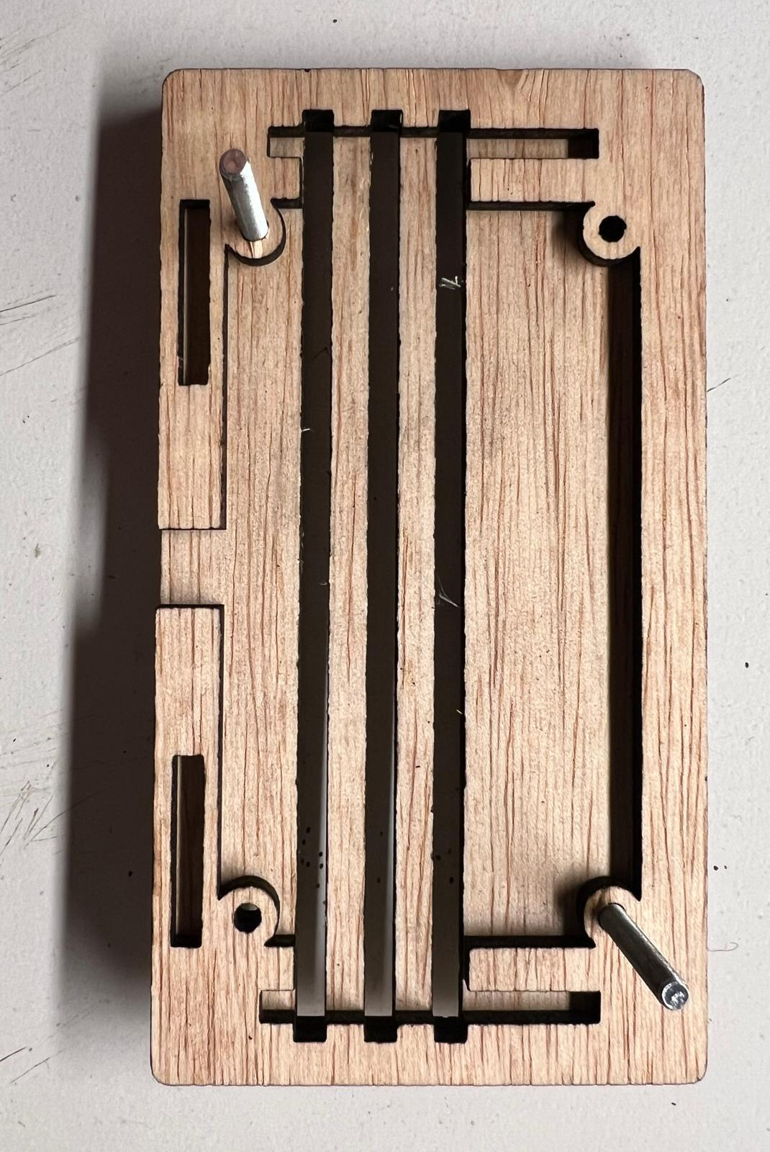

* And then the printed circuit board with the microprocessor, the light sensor and the LEDs follows. Make sure that it is oriented exactly as shown. When you turn it around, you should see the top of three LEDs through each of the slits. A green circuit board with white and white connectors

  Description automatically generated
* Now put the remaining plastic rings on, one on each bolt.
  + They may not be exactly as shown below, but on the opposite corners. That is just fine.

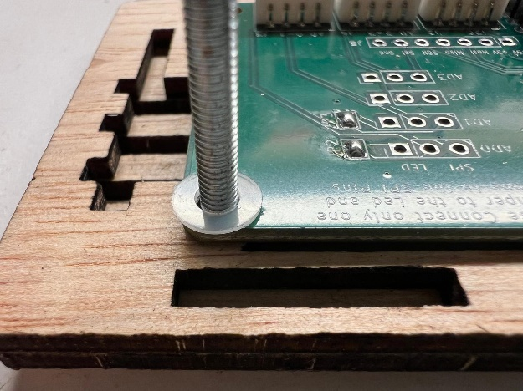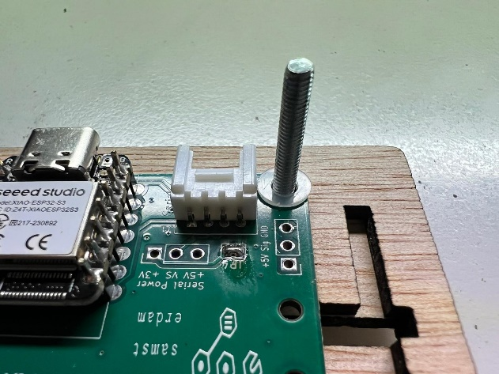

* Next put on the two remaining anti-slip nuts on the bolts and carefully thigten dem to fix the board to the top plate.
  + The nuts contain an anti-slip nylon insert. You’ll need plyers to hold the nut and a screwdriver to rotate the bolts.
  + **Do not overtighten the nuts.** You still need to be able to rotate the bolt with a screwdriver later to fix the bottom plate. So try this. If you cant turn the bolt, untighten the nut a wee bit until you can. A green circuit board with white and white connectors

    Description automatically generatedA close-up of a circuit board

    Description automatically generated
* Next insert the two small side boards (they are identical) into the side slits.
  + Be careful, they break easily. If you cannot press them in with a small bit of force, use some sand-paper to widen the slit a tiny bit.
  + Also make sure to attach the antenna (do not remove the paper from the antenna yet to expose the glue) to the board. The connector is a bit fragile. Make sure it is exactly above the other side on the board before you press. Ask for help when you are unsure.

* Time to put in the bigger one of the long sides. Again, be careful and use sandpaper if required.

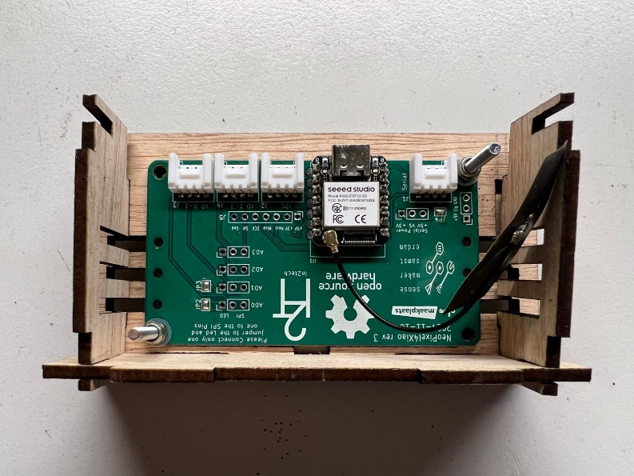

* Next the other long side. This is the smaller one. The text goes outside.
  + This part is quite thin in the middle. Breaks easily. You may want to try to fit it into the slots on the bottom plate and sand it up a bit if required first.
  + Now you also need to remove the paper protection from the antenna and glue it on the larger side panel. Make sure not to kink the cable!

* Next mount the bottom plate.
  + If you have the text on the outside, make sure it has orientation you want.
  + Carefully put the bolts into the beginning of the “tube” nuts and turn the bolts with the screwdriver.
    - Don’t do this bolt after bolt, bit rotate the first one half a turn, then the second one, then the first one, and so on. This way the bottom plate stays in position for the fingers and slots on the wood.
  + As soon as the fingers on the side panels touch the slots in the bottom panel, make sure they are well positioned. When necessary, guide the fingers into the slot before you tighten the bolts further.
  + Do not overtighten. When you do the box will lose shape or break. Stop before the top or bottom boards start bending.
* Finally put a plastic ring on each of the remaining bolts and screw them in from the top. 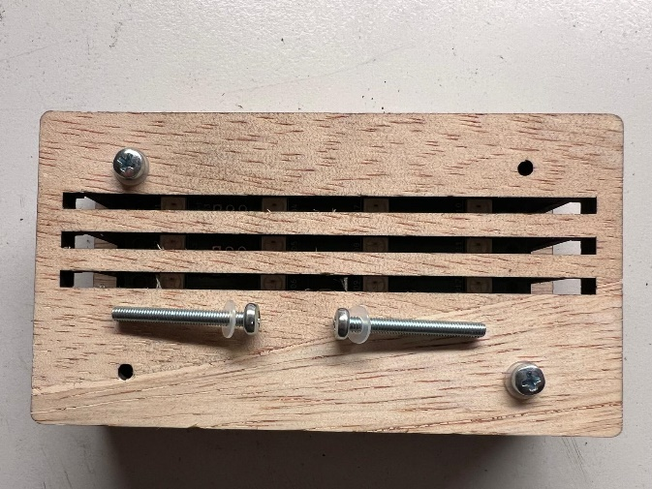
* The lamp feet should now look as below.

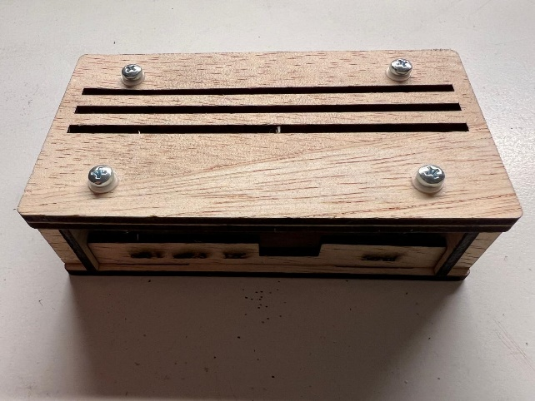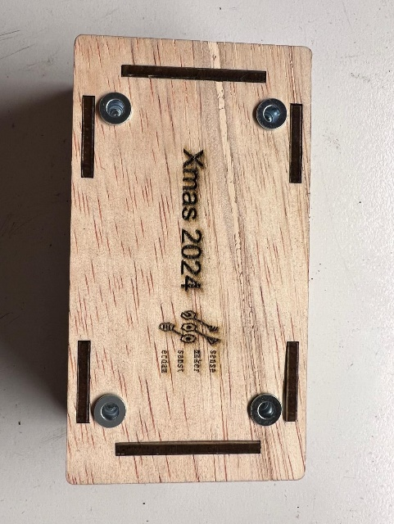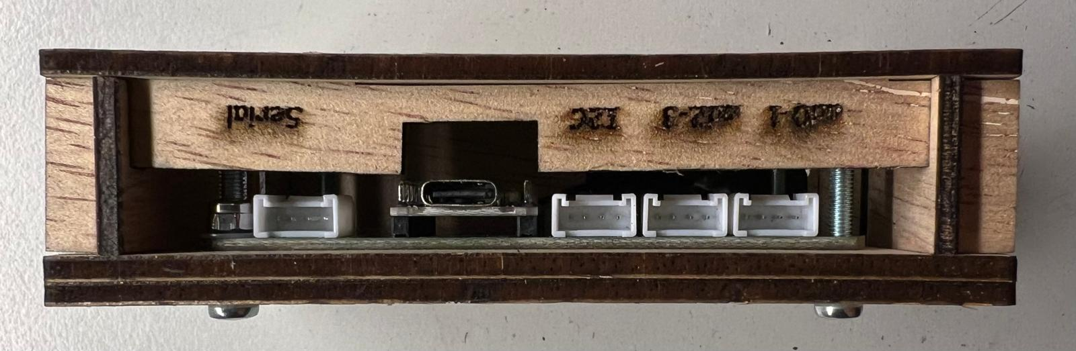

* We have a small number of self-gluing plastic thingies available to stick on as feet when you want to place the lamp on a sensitive surface. Ask for four when you need them and we have them.

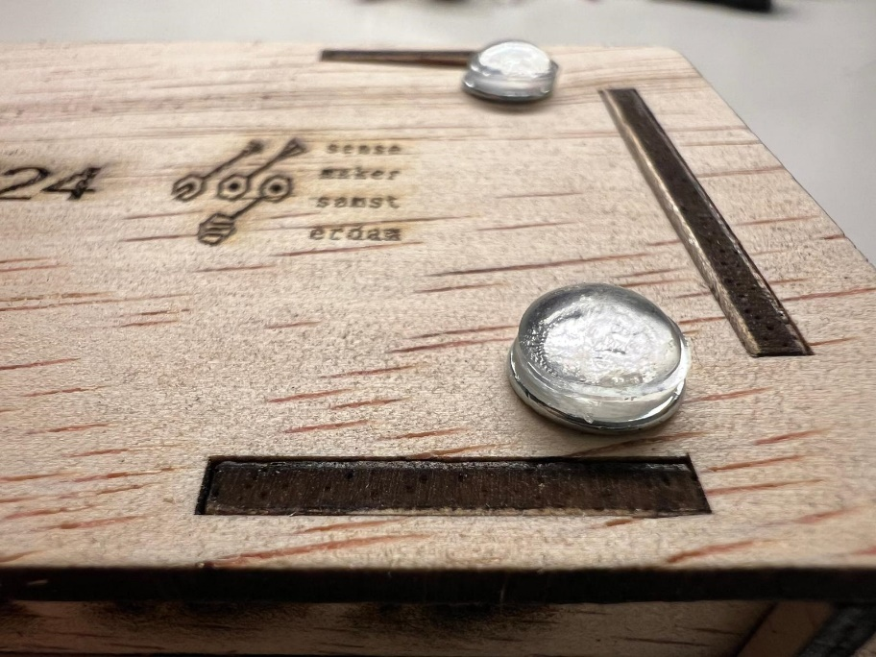

## And now

You need 3 acrylic slabs to finish the lamp. We have pre-engraved ones, or you can engrave some with our laser engraver (only with assistance), or manually engrave a slab with a Dremel. Please talk to us and we’ll get you going.

Please be very careful when inserting the acrylic slabs into the wooden base. Don’t tilt the slabs when pushing them in. You may need to widen the slits a bit first

And of course we will need to put the initial program onto your microcontroller and configure it for you to get the lamp going. This will be discussed in another paper.

# Have fun with your kit and a merry Christmas and a happy 2025 for you and your loved ones.